**LG F10C3QDP2 Washing Machine**

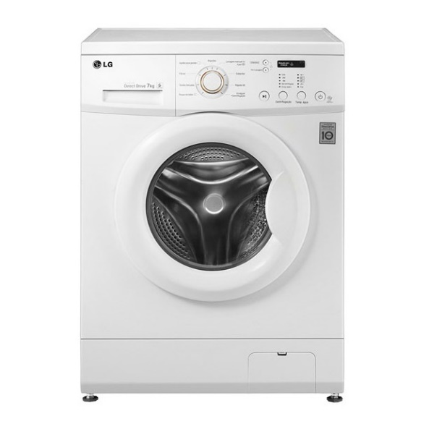

|  |  |  |  |
| --- | --- | --- | --- |
|  |  |  |  |
| **Capacity** | 7* |
| **Color** | White |
| **(Dimension) WxLxH** | 600*850*550 |
| **Drum Volume (litres)** | 58 L |
| **Options** | 6 |
| **Programs** | 9 |
| **RPM** | 1000 |
|  | **Weight( Kg)** | 62 |  |
|  | **WO** | Yes |  |